About me

Personal Information;

* Joshua Barton
* Student number S3793503
* Email [s3793503@student.rmit.edu.au](mailto:s3793503@student.rmit.edu.au)
* Grew up in a family who owned a computer store
* Moved away to be a part of the defence force
* Moved to QLD and become part of family business

Hi, my name Is Joshua Barton.

I have been around computers since being born as my family owned a computer store. From a young age I would go to the computer store and help out or play games on the computers. When I got older, I left school and joined the army for 6 years. Eventually I needed a change and I was still playing around with computers for fun.

I went back to the family business which had changed a lot, the family business was now providing cloud solutions to the insurance industry. I have been back working in the family business for two years and already picked up many new facts. I will need to learn a lot more to take over other jobs within the business and take it to the next stage.

I have been studying at the University of the Sunshine Coast for the past year but it was not flexible with work and family commitments, so I have changed over to RMIT so that I can study while I am away for work or have other commitments.

**Interests in IT**

My interests in IT began when I was at the computer store with my dad. He would give me tasks to do from a young age or I would play games on the computers to pass time. Eventually as I got older I would come along to client offices and help out with migrations. When I was 20 I joined the army and became a tank commander but became bored, so I left and joined the family business which I have been doing for two years now.

I have been studying at the University of the Sunshine Coast for the past year but it was not flexible with work and family commitments, so I have changed over to RMIT so that I can study while I am away for work or have other commitments.

During my studies I am expecting to learn many new skills and improve my knowledge in programming, system infrastructure, security, along with other subjects that I do not yet know about. By increasing my knowledge I am hoping to be more professional to take myself and the business to the next level.

**Ideal job**

My ideal job is to continue working in the family business. My current job tittle is support and migration specialist, which entails migrating new clients onto our platform and supporting them once they are on. I would like to take over more responsibility in the business.

The next position in the company will be to start taking over the management of everything. This appeals to me as every day is different, in small business you have to do marketing, sales, finance and support.

To take myself to the next level there are some skills that I require to improve on. I need to further my project management skills so that I can lead teams from multiple businesses on various projects. I need a better understanding on most areas IT to become a better generalist.

Currently I have completed four IT subjects at the University of the Sunshine coast. The subjects include project management and some basic programming. I have skills that I have learnt from day to day work which includes networking, cloud infrastructure, VMWare, cyber protection, etc.

To obtain the new skills required I will need to continue working on migrations and supporting end users as on the job experience gives you vital people skills and keeps you up to date with latest issues. I will need to continue university to get the latest ideas, techniques and procedures in the IT field.

**Personal profile**

For the Myers-Briggs test I was given debater. The debater is known for speaking their mind no matter of others feelings. In some ways I can see this as I can be very blunt but can pick the situation. I believe that to be successful you need to be blunt about issues even if it can hurt some ones feelings.

Myers-Briggs test – Debater

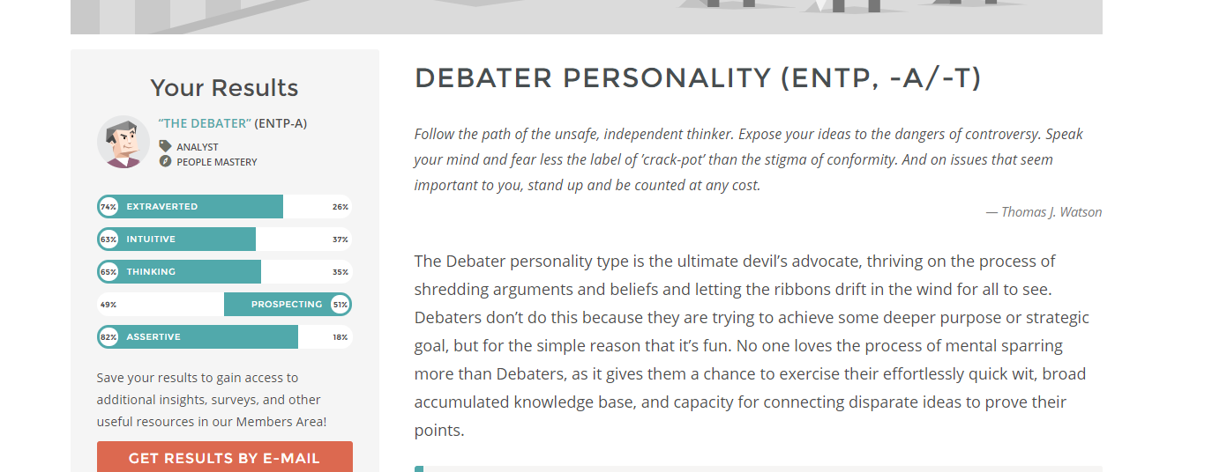

Source- 16Personalities 2019

For what’s your learning style test I scored high for tactile. Tactile learning is learning through doing, it is a hands-on approach. The results from this test match what I have found in the past from previous learning.

Online learning style test - Tactile

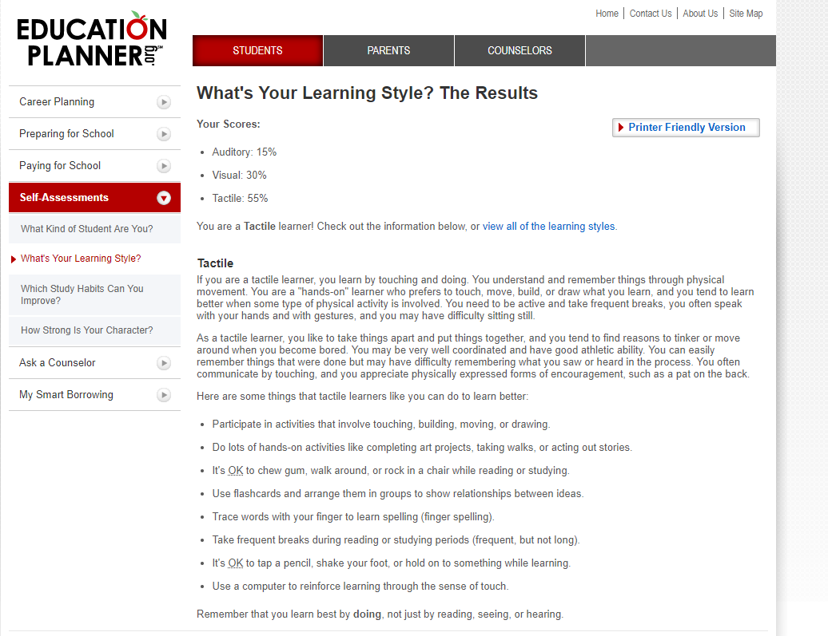

Source- Education Planner 2011

For the big 5 personality test I scored high in emotional stability and low intellect/imagination. Scoring low in intellect/imagination which means that I would be traditional and conventional which in some ways I am. Scoring high in emotional stability fits in with who I usually am keeping a level head under stress.

Big 5 personality test

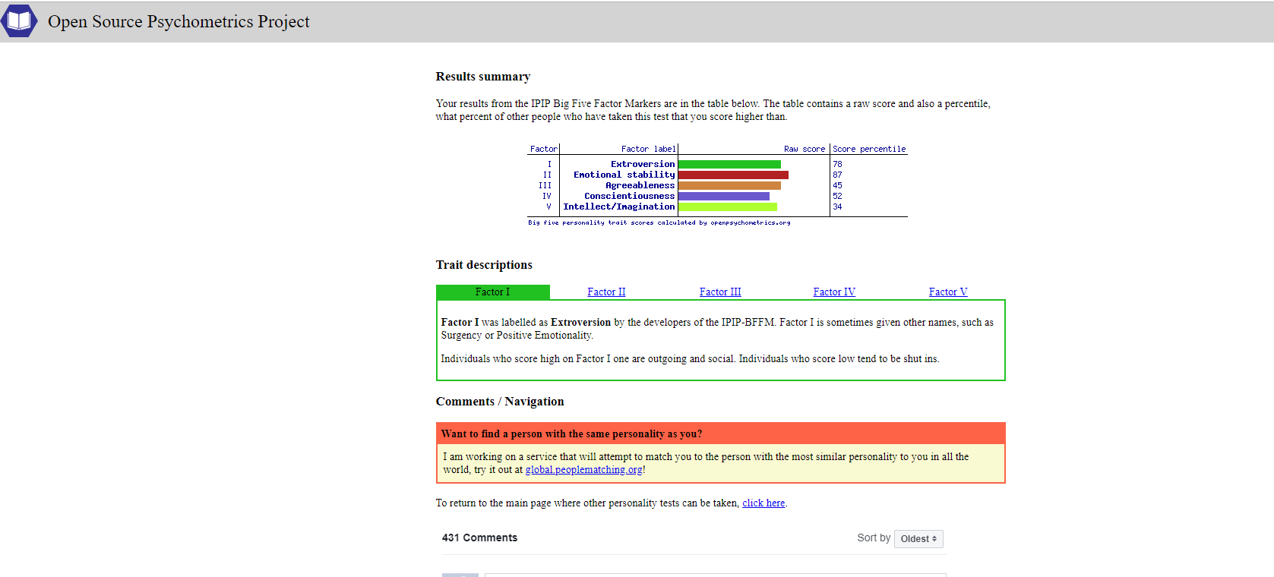

Source- Open Source Psychometrics Project

The results of these tests seem to relate to how I see myself and how I have been told that I react.

After looking at the results while working in a team I may not be very imaginative and could argue my point aggressively. The results help to point out my flaws that I will need to take into consideration to be a valuable team member.

**Overview**

This project will be to utilize a raspberry pie along with lights that can change colours, a microphone and a speaker to make a baby soother. When a baby is a poor sleeper the raspberry pie will attempt to train the baby to sleep recommended hours utilising a sleep schedule and react to baby waking then attempt to settle the baby utilising the speaker and lights. The device will also train the parents on things like how long to wait before manually settling the baby, what to do to settle baby, etc.

**Motivation**

There are many guides on how to get your kids to sleep with many theories, the goal of this project is to give parents a tool to tell them what to do at any given time and assist the baby to go to sleep. Poor sleep in children has been found to be negative on children’s overall health, with the rate of obstructive sleep aponia being around 2% to 3% in children (Krader & Honaker 2018). Raspberry pi is an easily adaptable and cost effective product that can be utilised in this product.

**Description**

Parents often battle with their children to get them to sleep. This product will be placed in an infant’s room, when the infant wakes a microphone will hear the baby making noise like crying or laughing, which will trigger the device to start playing white noise and/or illuminating the infant’s room with a light attempting to soothe the infant back to sleep. If the infant remains awake for a certain amount of time and the soothing does not work, it will alert the parents to come and manually soothe the infant for a certain time when it will let them know what to do next, corresponding with an escalating schedule. This will repeat until the infant has been settled back to sleep. If the infant is sleeping for a longer period than recommended, then the device will start a slow wakeup routine where it could start lighting up the room with the built in light and/or playing sound through the speaker.

A raspberry pie will be used as it can be easily implemented with the other equipment within and can be connected to the internet to achieve tasks like sending a sleep report to the parents or taking updates. A speaker will play white noise and other noises that are recorded onto the device. A light will be on a dome on top of the device and can be changed depending on the schedule for example a blue light to wake the infant in the morning or a red light to soothe at night. There will be a USB port on the exterior of the case for updates and possible future expansions. Possible future expansions could include an infant’s vital monitor that monitors the infant’s heartrate and breathing to prevent SID’s, a baby monitor linked to an app on a phone, a camera so the parents can check on the infant and a thermomotor so the device can give a guide on what to dress the infant in.

This device will follow a schedule of the parent’s choice and age of the child which corresponds to a professional’s recommendation. The schedule should include hours the infant should be awake/asleep, time that the infant should be soothed for before human intervention is required and escalation if required.

Further research is required on safe cable management to prevent infant chocking on charge cable or pulling the device off of a shelf. Ways to mitigate this could be a sticky surface below the device to prevent the device from being pulled from the shelf or having the device powered by batteries.

**Tools and Technologies**

The device will be made up of a raspberry pi, speaker, microphone, colour changing light and it will all be contained within a protective case. The device will run on a raspberry pi with a program written in python programming language due to its simplicity and efficiency.

**Skills Required**

Due to the device utilising python as its program language, knowledge for python will be required. According to TIOBE (2019) Python is currently the 3rd most common programming language in the world. Since python is the 3rd most popular programming language there is a large library of help available online. Raspberry pi is also common and readily available with many sensors/ad-ons available along with a large community support network. A specialist may be required to have the device functioning correctly and efficiently.

**Outcome**

If this product is successful, health of children and parents could be improved with infants sleeping for recommended periods of time. The device could simplify complex sleep schedules and assist parents to follow the recommended schedule. Healthcare professionals could also use data collected by the device to give further recommendations or diagnose sleep aponia in children.

References

16Personalities 2019, accessed 16 March 2019, <https://www.16personalities.com/entp-personality>

Education Planner 2011, *What’s your learning style*?, accessed 16 March 2019, <http://www.educationplanner.org/students/self-assessments/learning-styles-quiz.shtml?event=results&A=3&V=6&T=11>

Krader, C.G. & Honaker, Sarah Morsbach,P.H.D., C.B.S.M. 2018, "Sleep management is crucial for infants and young children/COMMENTARY", *Contemporary pediatrics,*vol. 35, no. 12, pp. 27-28.

Open Source Psychometrics Project, accessed 16 March 2019, <https://openpsychometrics.org/tests/IPIP-BFFM/results.php?r=3.7,3.9,3.7,3.4,3.6>

TIOBE 2019, TIOBE Index for March 2019, accessed 16 March 2019, <https://www.tiobe.com/tiobe-index/>